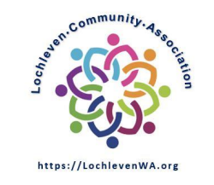
Date 03/07/2023
Member meeting for Bylaws draft comments

Approval Statue [Approved on 3/22 board meeting]

Meeting Starts: | 7:02 PM
Meeting Ends: | 7:22 PM

In attendance:
Board member | Members | Others
- Scott Lampe  - Wayne Novak  - Yuan Zheng  Bylaws committee  - Steve McConnell  - Mark Walters  - Scott East | Becky Walters  Lousie Boothroyd  Mike Hatmaker  Irina Gracheva  John Fuller  Chuck Doland  Nicole Myers

Minutes
Scott Lampe summarized the Bylaws update timeline:
- 2/24 emailed draft documents to the entire membership.
- 3/7 (today) member meeting for public commenting
- 3/10 deadline for comments
- 3/24 final documents ready for review. This is also the record date.
- 4/4 membership meeting to vote on the approval of the documents.
Comments were made by the following members (3 minutes each):
- Mike Hatmaker
- Louise Boothroyd
- Chuck Dolan
7:22 Meeting adjourne

